# System’s parameters

The system studied is the robot subdivided into three global parts (the head, the central body, the frame itself divided into the tank and the wheels compartments)

The choice of some electronics parts of our system imposes us the following constraints:

* Screen size:
* Une image contenant diagramme, croquis, Dessin technique, Plan

  Le contenu généré par l’IA peut être incorrect.Une image contenant texte, croquis, dessin, art

  Le contenu généré par l’IA peut être incorrect.One battery size: $\left\{\begin{aligned}\begin{matrix}Li-ion:3.7V for 2600mAh \\ Length:6.5cm\end{matrix} \\ Width:2.2cm \\ Depth:1.9cm\end{aligned}\right.,$ because of the requirements energy of our system, we propose the configuration of 3 parallel of 4 series such as the following configuration, whose allows us to product 14,8V for 7,8Ah.

This configuration will require approximately 13.2cm of width for 13 cm of length.

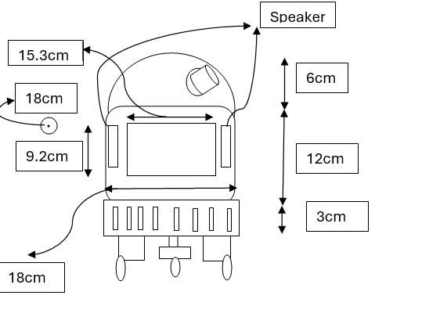With these constraints, we begin the sizing process with this figure:

# System’s volume

## Central body volume

$$V_{1}=18*18*12≈4000{cm}^{3}$$

## Tank volume

$$V_{2}=3*18*18≈1000{cm}^{3}$$

## Head volume

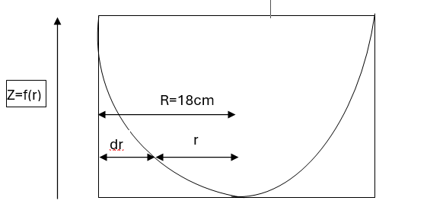We suppose that the head is an elliptical dome included in a cylinder of 6 cm of length for 18cm of diameter. And we found out that the best approximation of the head cure of R2D2 is $z\left(r\right)=\frac{H}{R}\sqrt{R^{2}-r^{2}}$. We consider an elementary surface at the altitude z in the zone delimited by the head curve.

The area of those surface is $A=πr^{2}=π{\left(R-dr\right)}^{2}=πR^{2}-πRdr$

$$(the element dr supposed the smallest, {dr}^{2 }is for sure inexistant in the same consideration.$$

So, the value of the volume inside the head is:

$$V_{h}=πR^{2}H-\int_{0}^{R}{πRz\left(r\right)dr}=πH\left(R^{2}-\int_{0}^{R}{\sqrt{R^{2}-r^{2}}dr}\right)$$

$$=πH\left(R^{2}-{\left[\frac{r}{2}*\sqrt{R^{2}-r^{2}}+\frac{R^{2}}{2}\arcsin{\frac{r}{R}}\right]}_{0}^{R}\right)$$

$$D^{'}où V_{h}=πHR^{2}\left(1-\frac{π}{4}\right)$$

And with the numeric application, the result is: $V_{h}=π*6*{18}^{2}*\left(1-\frac{π}{4}\right)=1310{cm}^{3}$

## Volume final

we consider the volume of the wheel container equal to $1000{cm}^{3}$ (400*2+200)

With this supposition, we conclude that the volume of all the system is $7310{cm}^{3}$

So, we can conclude that the mass of our system is approximately 16,1Kg (by oversizing him supposing that the entire system will be full of the matter of the hull whose is the PTFE with the density of 2.2g/ ${cm}^{3}$).

# Required strength

Firstly, we suppose that the speed of our system will be between 0 to 18Km/h and that his optimal speed is at 9Km/h that to say 2.5m/s for an acceleration of 0.25m/s².

The applicated strength is:

* The weight $\vec{P}$
* The vertical reaction $\vec{R}$
* The friction $\vec{f}$
* The engine strength $\vec{F}$

The application of the inertia principle gives us:

$\vec{f}+\vec{R}+\vec{F}+\vec{P}=m\vec{γ}$; so $\vec{F}+\vec{f}=m\vec{γ}$; so $F=mγ+f=16.1*0.25+0.6*16.1*9.8=98.693N$

So, each wheel must give approximately 50N

# Required power

We earlier suppose that the volume of the wheels containers is up to 1000 ${cm}^{3}$, considering one container, who was supposed to have a volume of $400{cm}^{3}$, we can consider that one wheel has a volume of $300{cm}^{3} and that only 200{cm}^{3}$ is in the container. With that, we impose that the size of the wheel is 11.2cm of diameter and 2.03cm in width.

So, we conclude that the required engine couple given must be

$$C_{M}=F*r=50*0.056=2.8N.m.$$

So, every engine must give a couple of 2,8N.m.

We want our wheels to have a speed of 2,5 m/s that to say 500tr/min (~426.31tr/min) for a diameter of 11.2 cm that to say a perimeter of 0.352m.

We conclude that the engine must train the wheel to 44.64rad/s, equivalent to P=44.64*2.8=125W

In conclusion, we need an engine who can produce **125W at 50rad/s**